Visiting Cape Cod > April 2021

As Spring arrived and the pandemic slowly ebbed, it was time for our annual visit to Cape Cod, MA. Our 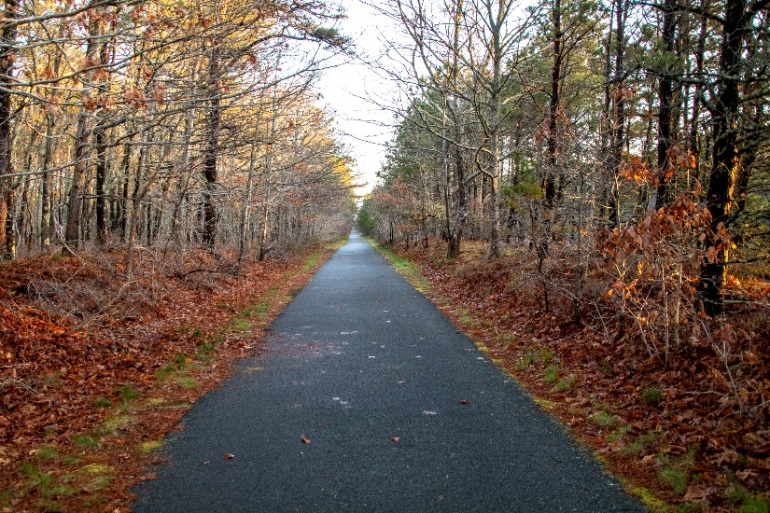favorite haunts were open from Orleans to P–Town and we thoroughly enjoyed the outdoors activities, occasional shopping, and the always different food choices. There is nothing like a 2-mile walk on the Bike Trail before breakfast followed by visits to familiar locations offering different enticements. The weather was quite cool and windy, but each day offered excellent opportunities to explore the arm from First Encounter Beach in Eastham up to the Race Point beaches at P-Townand many spots in between. No whales or live dolphins, but it was not for lack of looking.

As for the photos, click on the [Cape Cod – April -2021](https://photos.app.goo.gl/YSqgVQ8bc5SP6cGXA).